Following the direction and codes from this website:
First: set up Google API https://www.ryanpraski.com/python-google-analytics-api-unsampled-data-multiple-profiles/; In case the website moved, this is a pdf version of the website in the folder.

Second: use a python script to pull more than 5,000 (100,000+ in my case) from Google API
Website: https://www.ryanpraski.com/python-google-analytics-api-unsampled-data-multiple-profiles/
Pdf version is also in the folder

Note: Ryan Praski’s python code is written in Python2, the syntax is a little bit different from Python3, specifically:
- In python2, print function is print ‘text’; but in python3, it’s print(‘text’).

- Error Handling: In python2, you write this if you expect an error:
try:
trying_to_check_error
except NameError, err:
print err, 'Error Caused'
# Would not work in Python 3.x
In Python3, you use except NameError as err: instead

- xrange in python2, is just range in python3

Also: the google-api-python-client in Ryan’s package is out of date. You need to update it with pip through command prompt.
You might get error messages like:
- No module named googleapiclient.discovery
- ImportError: No module named oauth2client.client
No big deal, just search these errors in Google and they will provide a simple update code to solve it. For example, the above problem can be solved with:
- pip install --upgrade google-api-python-client
- pip3 install --upgrade oauth2client

Overall workflow:
I use the first guide to setup the API. Once I got the GUI Query Explorer working, I jumped to the second site that teaches you how to use that python script.
I obeyed Ryan’s guide all along, though since the post was made years ago, I have to solve some updating problems. If this guide is confusing, look at Ryan’s website.

Install python:
You can install python2 and use Ryan’s code (with modification on account and filenames, etc.)
Or
You can modify it so that python3 runs Ryan’s code (specific modification is shown above).

Register for Analytics API in Google Developers Console:
The link to Google Developers Console: https://console.developers.google.com/flows/enableapi?apiid=analytics
You will see this. Agree and Continue, API is enable
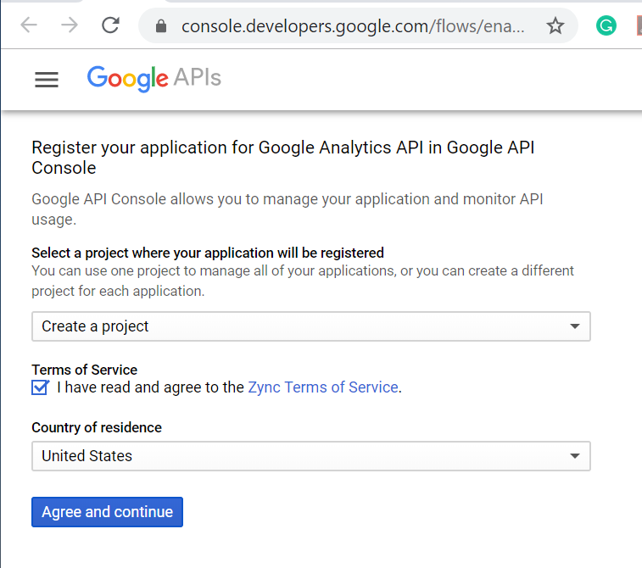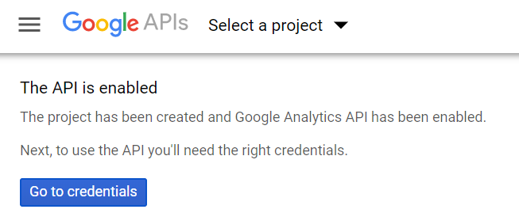

Then, you will need to setup API credentials on this page:
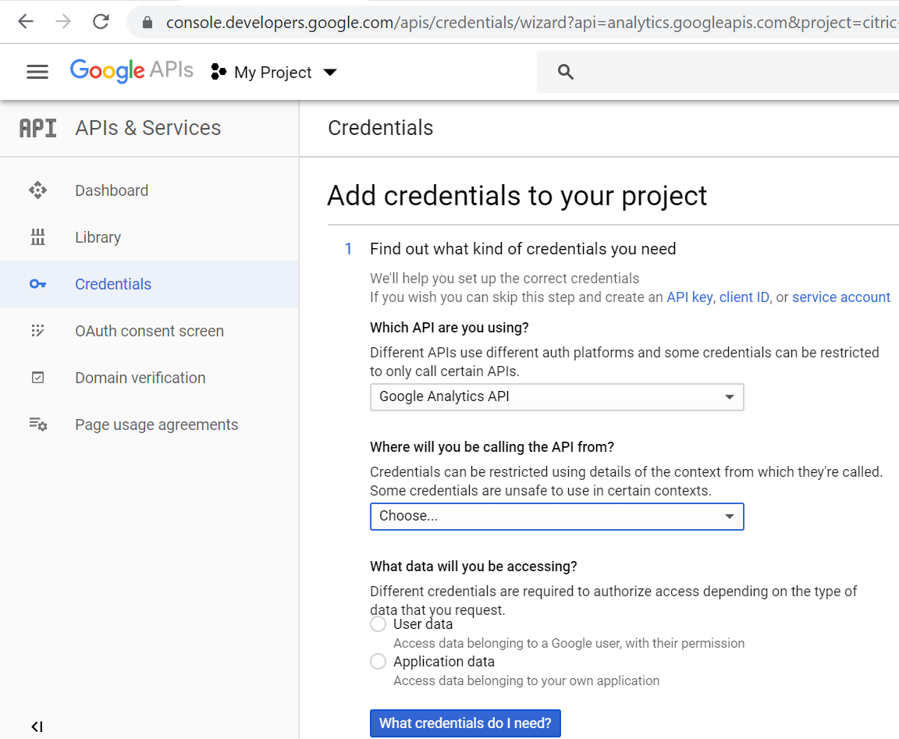
But, before you setup credentials, we need to Configure OAuth Consent screen. I’m working for Carleton College, so my API is internal. Ordinary @gmail.com can only choose external.
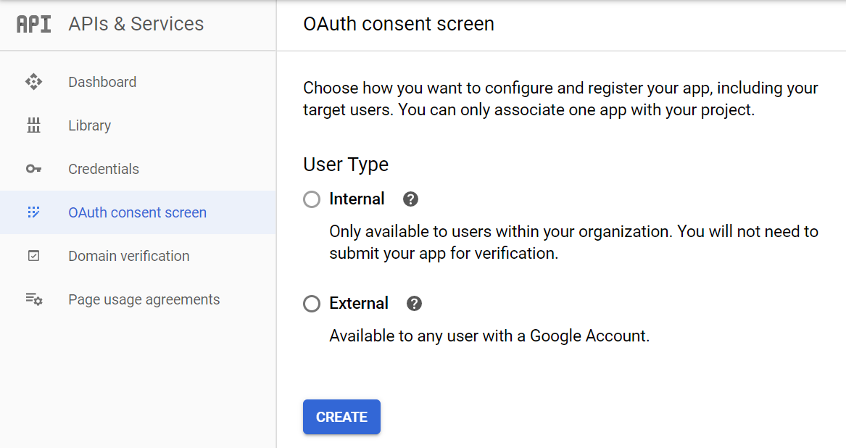
Fill in Application name and authorized domains (the school website)
The “save” button won’t appear unless you’ve filled in both of them.
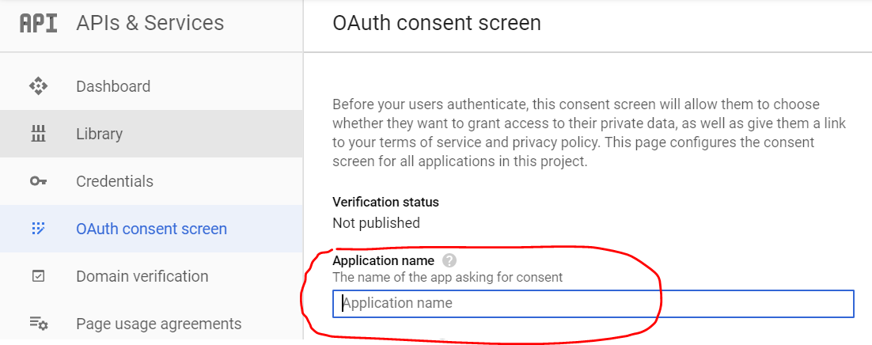
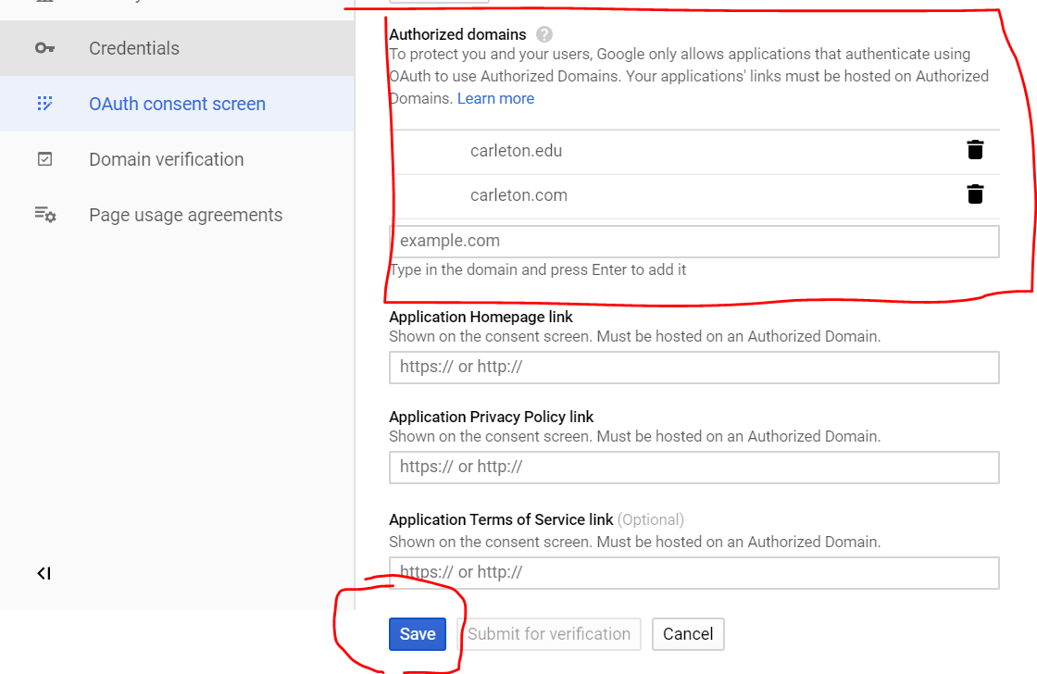
Go back to Credentials and we will configure OAuth client ID as authentication method. (so when Ryan’s python program runs, there will be a google login window that pops up)
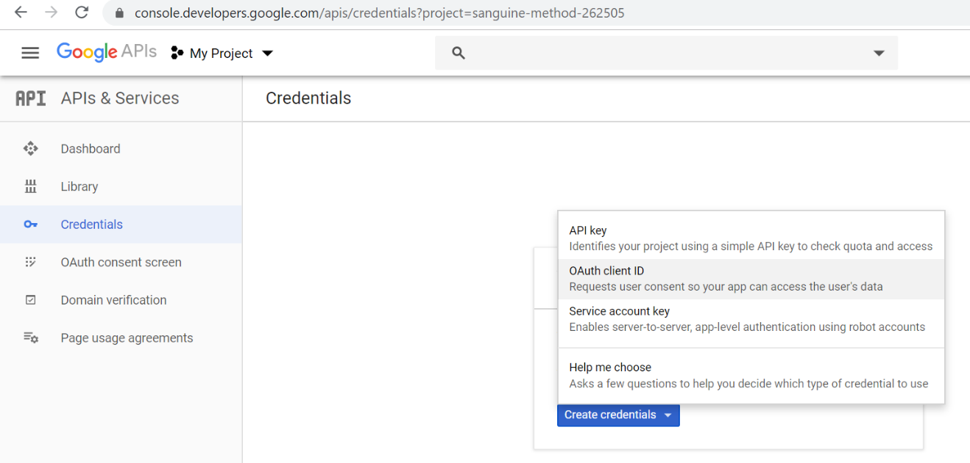
We are using a python script, so choose “Other” for Application type
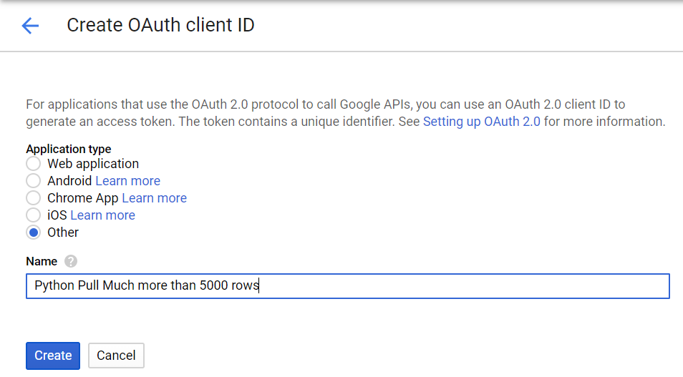
Save client ID and client secret. We don’t need to use it for this project, but I think it will be useful in the future. (I bleared it because I’m using my personal account for screenshots)
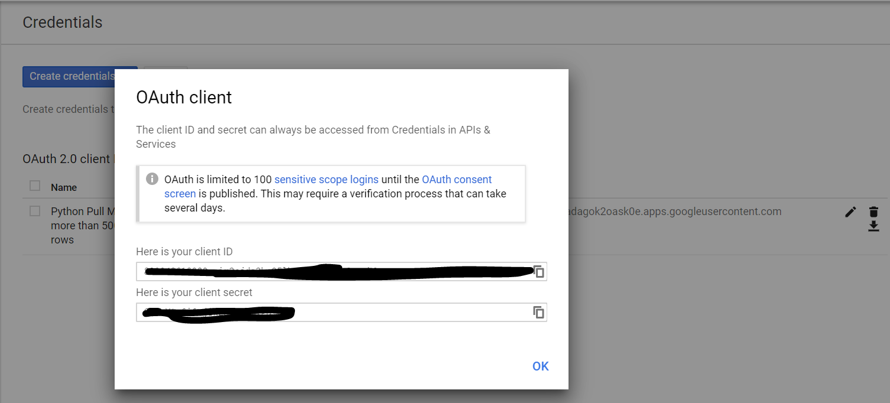

Download Google API sample code to use Client Google API
The link to the sample code is here: https://github.com/google/google-api-python-client/zipball/master; The downloaded file is a zip folder about 100MB.

This part is completely copied from Ryan’s website:
Add Your Google Analytics API Client Secret Credentials
In the Google API client samples folder you just saved, open the analytics sample folder.

\google-api-python-client-master\samples\analytics

Open the client_secrets.json file in a text editor. I use NotePad++. Right click edit with Notepad++. Delete all the text in this sample client_secret.json file.
Find the client_secret.json file that you created and downloaded from the Google Developer console at the end of Step 4. Open your client_secret.json file in NotePad++ and copy the text in your file (this has your API credentials) and paste the text into the sample client_secrets.json file that was in the analytics sample folder. Make sure to save the file.

Run your first Google Analytics Report Query using Python
In the analytics sample folder the path to the folder for me is C:\Users\ryan\Desktop\google-api-python-client-master\samples\analytics
Right click hello_analytics_api_v3.py file and choose to Edit with IDLE. Do not double click the hello_analytics_api_v3.py file. IDLE is the integrated development environment for Python

In the top nav menu go to Run > Run Modulerun hello_analytics_api_v3_module
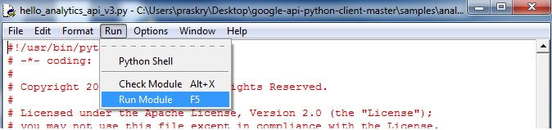

The Python Shell should open and you should see a message in the Shell that says “Your browser has been opened to visit: https://accounts.google.com/o/oauth2/…”run hello_analytics_api_v3_shell_authenticate
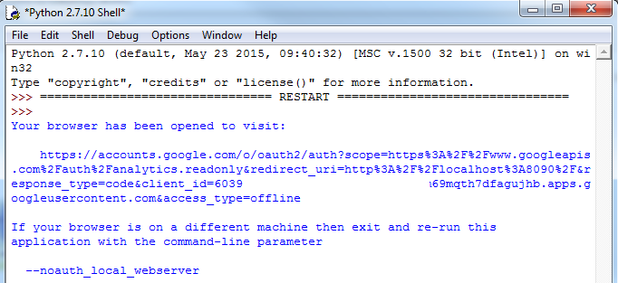

Your browser will open asking you to Allow access to View your Google Analytics data for your Google Analytics Python API application. If you are logged in as multiple Google users and the application asks to authenticate for the wrong user, you can take the URL and copy and paste it in a browser window with the correct user logged in.
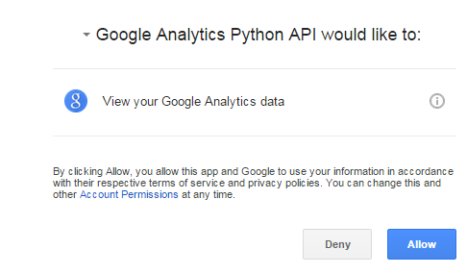
After clicking Allow you will see a web page with the message “The authentication flow has completed”
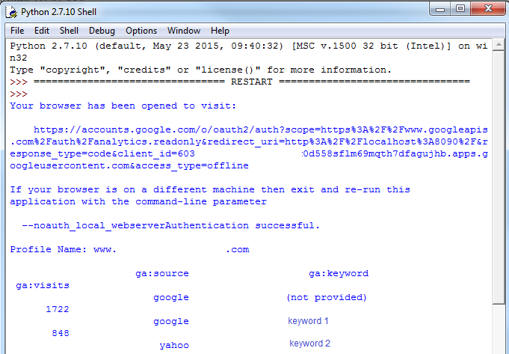

Back in the Python Shell you’ll now see the results of your query. You should see visits (sessions) to the top 25 organic keywords from January 1, 2012 to January 15, 2012 for the first view your Google Analytics user account has access to. If this query has no data for this time period or for these dimensions have no fear, in the next steps I’ll show you how to build your own query.

<-------------------------------------------------end of excerpt from Ryan -------------------------------------------------------->

If you receive any error message in this process (which you should), that because the Sample Client Google API is out of date.
Since Client Google API (supported by Google) is ever changing, the link to download is outdated. You have to do the updates in the beginning (or more) to keep you Google API up-to-date.

Play with Google Query Explorer
This part is not necessary to complete the project, but Google Query Explorer gives you a good understanding (it has a nice GUI interface) before digging into python codes. The fields that you modified in the python script are identical to that in Query Explorer
Link to Google Query Explorer: https://ga-dev-tools.appspot.com/query-explorer/

You will need to register. And apparently this interface cost money (and asks for you credit card information). It gives you a free trial of $300 dollars. I used my personal credit card because Google explicitly states that they will ask me when the free trial use up and when they charge my credit card.
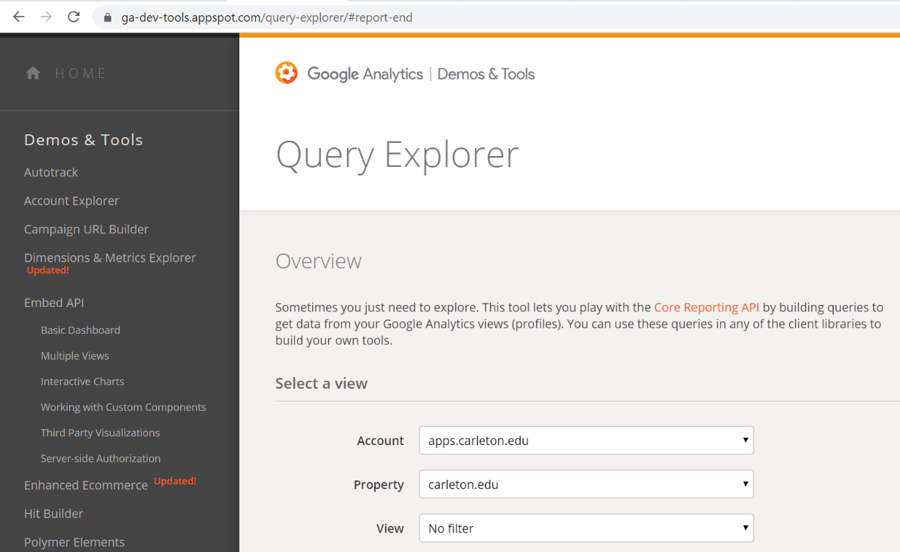

After registering and getting into Query Explorer, fill in the information as those fields tell you to. For example, you account information, the website that you want to look at, which view you look at, and the range of date that you want to look at. The metrics and dimensions are the same as in Google Analytics account that I log into yesterday.
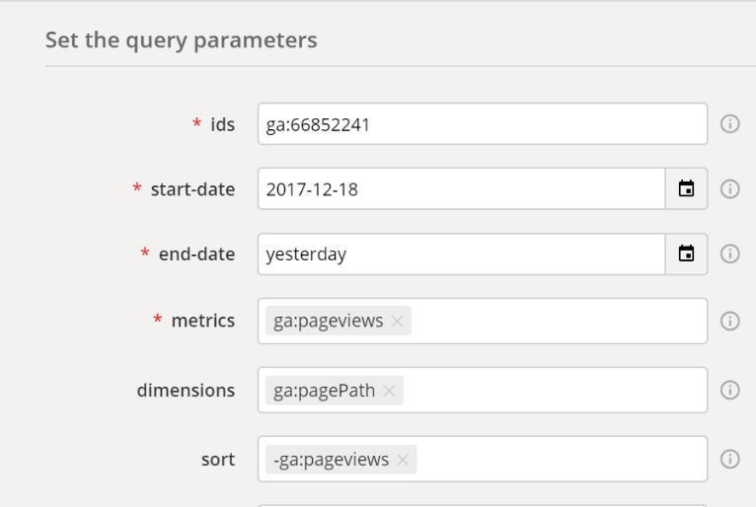

Query Explorer is better than the Google Analytics interface in that it’s faster (about 10-20 secs), and you can draw upto 10,000 rows at a time (only 5000 in the interface)
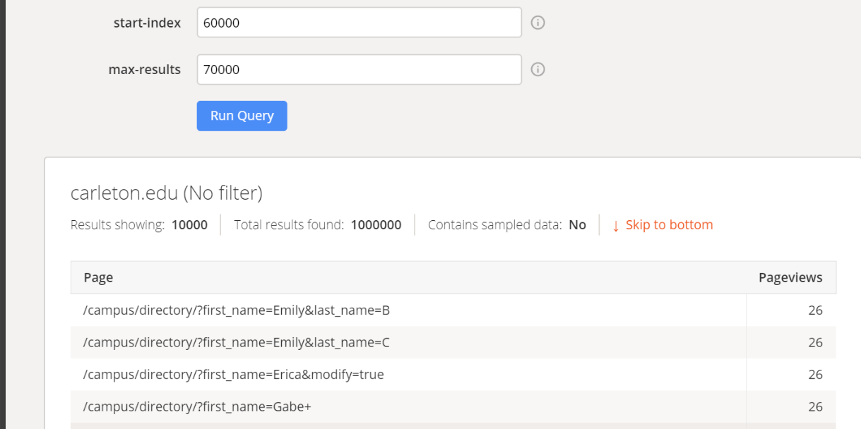

Use a Python Script to Pull Much More than 5,000 rows:
By now, your computer is already authenticated by Google Query. The specific step is when you go to
C:\......\Desktop\google-api-python-client-master\samples\analytics, and open hello_analytics_api_v3.py; open a Google login screen.
Ryan’s original script and my modified script for Python3 are both in this folder:
https://drive.google.com/drive/u/1/folders/1xMzMMWfA9vCjDFZ7LzcSsG-_V5DG0pkU
Make sure it’s in folder C:\......\Desktop\google-api-python-client-master\samples\analytics (the same one as hello_analytics_api_v3.py.

Open this script, no matter which script you are using, you always need to configure parameter like you did in Google Query Explorer, specifically:

- Go to line 162, find profile_ids={‘ryanpraski’; ‘1234567}, or profile_ids = {'apps.carleton.edu': '66852241'}. Enter the profile name (the name of the output csv file) and profile id (view ID from Google Analytics) that you want.

- Go to line 165, and enter the date range you’d like for your query. Note that this program can only get 10,000 queries from the API at a time, but it can compile multiple 10,000 queries and make them into a big one. So, for a large entity like Carleton website, I can only select one month as the range.

Possible Error:
If you receive “Error: Query contains sampled data!” your query will not run.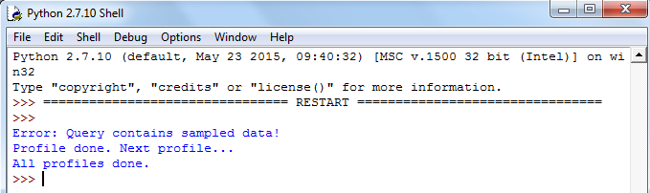
Then, shorten the date_ranges variable until this error message doesn’t appear again.
Also: There is an option where you can select multiple range of dates. The result click counts, however, doesn’t add up. They are just a month after a month, so I didn’t find it really helpful.

- Find the filename variable on line 176. This is the name of the output csv file. %s is a placeholder variable, %s <= the profile name in step 1. For example, my filename will be google_analytics_data_apps.carleton.edu_1.csv.

- Fn + F5, run the script. If everything is right, you should see this:
Open the csv file with excel or any statistic software you like.
